Course Code: CSA1305 Name: Elango M (192411026)
Faculty: Dr Balamanigandan R
EXPERIMENT NO: 17
Title
Design Turing Machine using simulator to perform subtraction of aaa-aa
Aim
To design a Turing Machine (TM) using the simulator to perform subtraction of aaa - aa.
Software Used
- AutoSim / Automaton Simulator
- Windows Operating System
Procedure
- Open the Automaton Simulator.
- Select the Turing Machine option.
- Create the required states.
- Select the initial state.
- Mark the final/accepting state.
- Define the required tape symbols and transitions.
- Enter the input representing aaa-aa.
- Run the Turing Machine.
- The machine removes/subtracts the second group of as from the first group.
- Observe the remaining as on the tape.
- Record the final result.
Algorithm
- Start the Turing Machine.
- Read the first operand aaa.
- Locate the second operand aa.
- Match one a from the first operand with one a from the second operand.
- Mark/remove the matched symbols.
- Repeat until all symbols of the second operand are matched.
- The remaining symbols from the first operand represent the subtraction result.
- For aaa - aa, one a remains.
- Move to the final state.
- Stop.

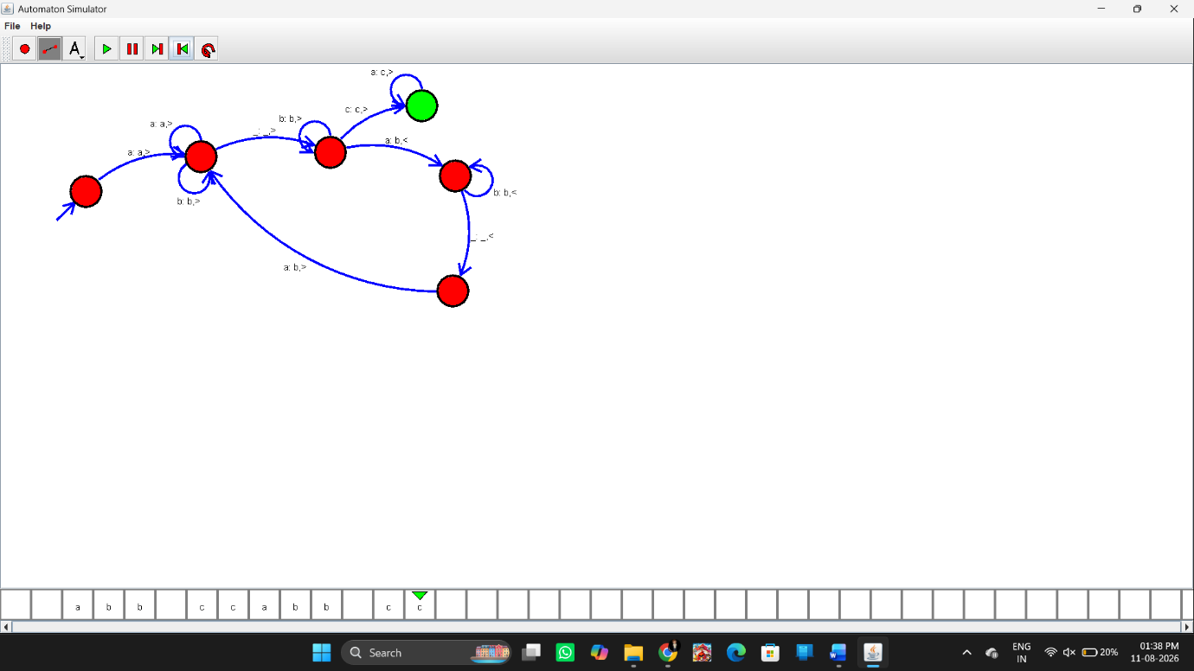Input
As specified in the manual:
aaa-aa
Output
The manual explicitly gives the result:
The Result of Subtraction is = a
Result
Thus, the Turing Machine was successfully designed using the simulator to perform subtraction of aaa-aa, and the resulting output is:
a

